TABLE OF CONTENTS

CHAPTER NO. TITLE PAGE NO. LIST OF FIGURES 06

ABSTRACT 07

1. INTRODUCTION
   1. PROBLEM OBJECTIVE 08
   2. LITERATURE SURVEY 08
   3. METHODOLOGY 10
2. GEO-FENCING
   1. MODULES 11
   2. METHODOLOGY 12
      1. CREATING A BOUNDARY AND OBTAIINING LOCATION 13
      2. IDENTIFYING INTRUSION 14
3. ALGORITHM
   1. CREATING A VIRTUAL BOUNDARY 15
   2. CHECKING INTRUSION
4. OUTPUT 16
5. ERROR ANALYSIS 17
6. CONCLUSION 18

|  |  |  |
| --- | --- | --- |
| FIGURE NO. | TITLE | PAGE NO. |
| 1.1 | News journal | 09 |
| 1.2 | Literature Survey Clipping | 10 |
| 2.1.a | NEO 6M GPS Module | 11 |
| 2.1.b | NEO 6M GPS Module working | 12 |
| 2.2 | Visualisation of a Geo fence | 12 |
| 2.3 | Live location by GPS Module | 13 |
| 4.1 | Output display | 16 |

LIST OF FIGURES

# ABSTRACT

Geo fencing is a technology which is being used recently for various purposes of tracking and navigation. Geo fencing is employed in our project for defining a Virtual boundary and detecting intrusions. A Neo-6M GPS module is being employed to obtain the location. It works parallel with the defined boundary, to indicate and update the current zone of operation of the boat. Further an alarm to indicate the protrusion. This paper encloses the description of our project work. It offers a study on the problem faced and a comprehensive analysis of solutions. It is a small step in solving this long lasting issue, which we were able to do in this shorter span.

Keywords—Geo fencing, virtual boundary, Neo-6M GPS module.

## 1.INTRODUCTION

### PROBLEM OBJECTIVE

We are living in a world where everybody faces problems, which gets solved one day or other. Similarly we came across a problem which is being faced by the Indian fisher man for a very long time. It’s a repeated story that the fisherman are being arrested and their boats being seized for intrusion into the SriLankan boundary. There is not a proper solution for this problem and they are forced to take punishment each time. So we are trying to come up with a small initiative as a solution for this problem. We are trying to indicate the fisherman that they are actually crossing the Indian boundary limit and they have to return their boats by that time. Such that they will not get into trouble.

So our project is primarily based on alerting the fisherman about their location and that they are intruding into the Srilankan boundary if they tend to do that unknowingly. It is a small step in solving this long lasting problem, such that it may be developed in the future and serve in real time**.** We have enclosed our entire idea in this report.

### LITEERATURE SURVEY:

Geo fencing involves the use of an app and GPS, RFID, Wi-Fi or cellular data to track the mobile devices of fishing boats or RFID tags on their vessels when they enter or exit a virtual boundary, or Geo fence. We have used Arduino, GPS module and a buzzer in our project with the help of which we try to alert the fishermen when they enter the virtual boundary that we have created.

### ANALYSIS OF LITERATURE SURVEY:

* Geo fencing is the basic idea behind the implementation of our project
* Geo fencing consists of establishing a virtual perimeter around a geographical zone and then connecting mobile devices to it; an alert is emitted when one of these mobile devices crosses the perimeter
* It is directly implemented within software solutions for tracking and managing mobile assets

### 

### NEWS JOURNAL:

### UDUPI: The fisheries department in Udupi plans to use location determining

### Technology to keep tabs on thousands of boats that dock at and leave, Malpe and

### Gangolli ports.

Figure 1.1

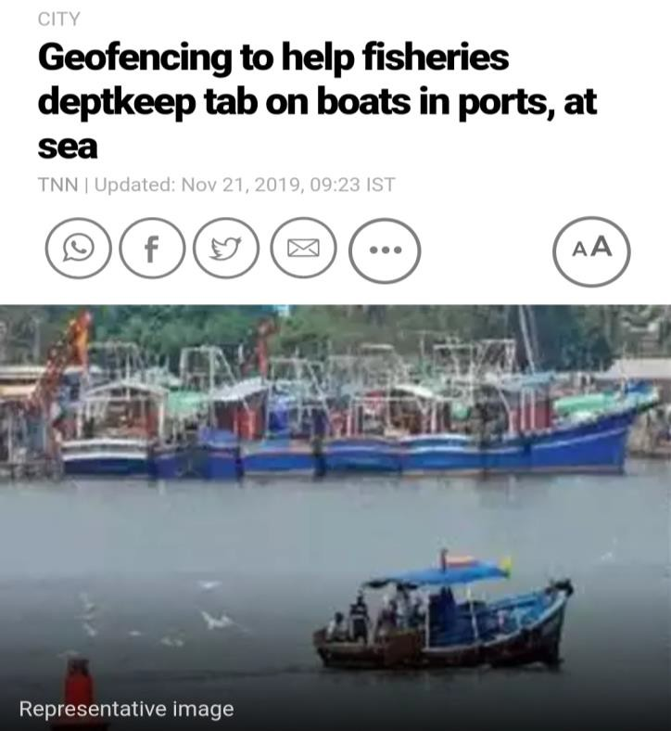

After successfully carrying out a pilot project with the technology known as geo fencing, on country boats, the department sent a proposal to the government asking for it to be made mandatory, a fisheries department official said.

Fishermen now use transponders which cost Rs.40, 000 each, and do not allow two way communication. Geo fencing is cheaper, costing just Rs.15, 000 .This news encouraged us to do project with geo fencing to help the Indian fishermen to get rid of the problem that they are facing, at least in a way.

### METHODOLOGY:

From the newspaper clipping figure 1.3, it is clear that not all crossing of maritime boundary is intentional .Taking this as our central theme and trying to find a solution for this, we came up with our project idea .Our project's main idea is to inform and make the fishermen aware of their location and to alert them if they tend to cross the border unknowingly .This would help them ensure that they are in a safe fishing zone.



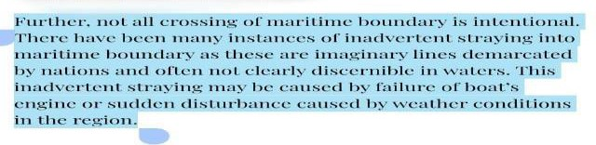

Figure 1.2

Introducing a system which works under the theme of ‘Geo fencing’ to alert the fishermen when they tend to protrude into Srilankan boarder is accomplished as our project. A GPS based alert system which keeps track on the current location and the virtual fenced boundary will warn the fishermen when they start reaching the vicinity of the border.

**2.GEO FENCING:**

**2.1 MODULES:**

**NEO-6M GPS MODULE:**

Figure 2.1 a

Figure 2.1b

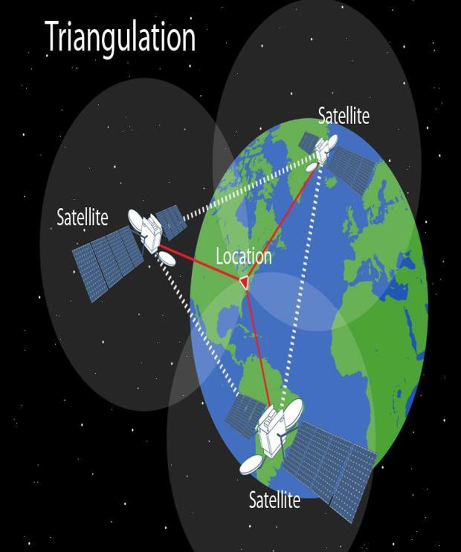 The NEO-6M GPS module is the main component of our project which receives the signal from the Global Positioning Satellite and connected to it for providing our live location.

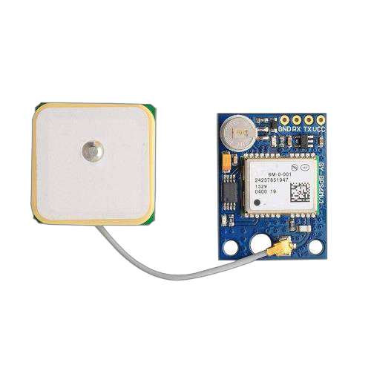

The NEO-6M GPS module is a well- performing complete GPS receiver with a built-in 25 x 25 x 4mm ceramic antenna, which provides a strong satellite search capability. With the power and signal indicators, you can monitor the status of the module.

The heart of the module is a NEO-6M GPS chip from u-blox. It can track up to 22 satellites on 50 channels an achieves the industry's highest level of sensitivity i.e.-161dB tracking while consuming only 45mA supply current GPS modules contain tiny processors and antennas that directly receive data sent by satellites through RF frequency.

2.2 METHODOLOGY:

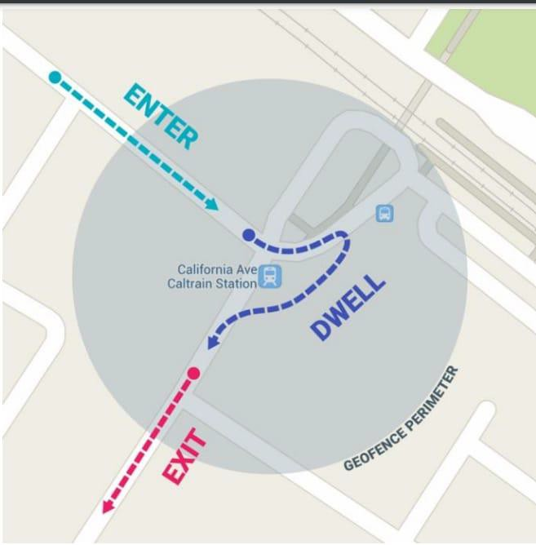 Geo fencing is the basic idea behind the implementation of our project Geo-fencing (geo fencing) is a feature in a software program that uses the global positioning system (GPS) or radio frequency identification (RFID) to define geographical boundaries.

Figure 2.2

The use of GPS or RFID technology to create a virtual geographic boundary, enabling software to trigger a response when enters or leaves a particular area.

A geo fencing is a technology that makes use of location data to set up an invisible barrier in the real world. Often the technology uses Global Positioning Systems (GPS).

You can't see or feel anything when passing through a geo fence, but when carrying a connected device, the system knows when you enter or exit the electronic boundary. The geo 'fence' operates on one device and picks a series of location points nearby to create an artificial boundary. It then connects with available networks, such as cellular or wireless internet, to exchange signals with other devices. If a device is broadcasting its location near the boundary, the geo fence can identify whether it is inside or outside the coordinates, and signal for a programmed action to occur While GPS can establish our location on the globe, Geo fencing focuses on where we are in proximity to virtual landmark.

### CREATING A BOUNDARY AND OBTAINING LOCATION:

The location around which a boundary has to be drawn is identified .Then the radius of the boundary is decided and specified in terms of latitude and longitude decimal degrees. Both these data is used to create a virtual boundary using the algorithm mentioned later in this report. Now for obtaining the current location we use a GPS module**.**

Using a GPS module, we get the current location information of the boat. We get the location in terms of latitude and longitude .This gets updated every second as the boat moves in the open sea .We are interested in ‘Latitude and Longitude in decimal degrees’.

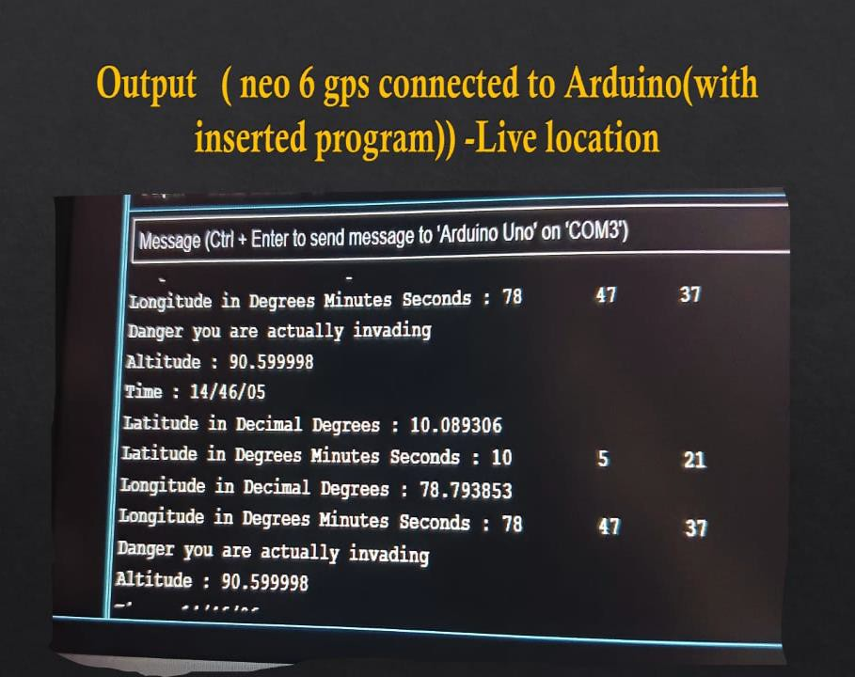

Figure 2.3

Now we have created a boundary and also will get updated regularly with the live location .With the help of these, we may now use an algorithm to check for intrusion and verify the safety of the event.

### 2.2.2 IDENTIFYING INTRUSION:

So how do we diagnose intrusion of boat in the virtual boundary? .With both live location and virtual boundary it can be accomplished easily using an algorithm. We just subtract the live location with the location taken as reference and compare it with the radius specified before. If the result is lesser than the radius,then we infer that the boat is inside the virtual boundary and display a danger sign using a Dc buzzer .Which insist the fishermen to return to the safe zone immediately .If the result is greater than the specified radius then we infer that the boat is in as safe fishing zone and may continue to do so.

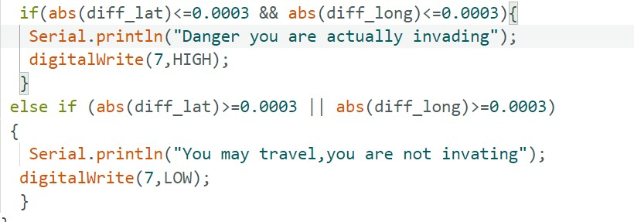

The above algorithm helps to diagnose the zone of operation of the ship and will direct them further to return to a safer zone after unintentional intrusion.

### 3. ALGORITHM

### CREATING A VIRTUAL BOUNDARY:

**Step 1**: Download ‘Tiny GPS’ library in Arduino IDE.

**Step2**: Decide the location around which a boundary has to be drawn.

**Step3:** Declare two variables for latitude and longitude.

**Step4**: Assign the corresponding latitude and longitude values of the chosen location to variables declared, in terms of degree decimal.

**Step5**: Choose the dimension of the virtual boundary and calculate it in terms degree decimal. **i.e. for 1m=0.00001207 & for 1km=0.012075 (**longitude change**).**

**Step6:** From the calculation done, **add** and subtract **the** dimensions from the location variables to get our desired boundary coordinates.

### CHECKING INSTRUSION:

### Step1: Now a boundary is created.

**Step2**: Power up the GPS module and wait till it gets connected with satellites. **Step3**: Once the GPS module is connected, it starts reading the current location of the boat and we extract only the location in terms of degree decimal.

**Step4**: Location is updated every second by the GPS module and we compare it with the location variables to find the modulus of difference. It is stored in a variable called diff_lat and diff_long.

**Step5**: Now an If condition is used to check for the zone of operation of the boat.

**Step6**: If the difference is less than dimension mention then we infer that the boat has already crossed the border. If it is greater than the variable then vice versa.

**Step 7**: An alarm which is connected to a digital pin and it is triggered if the boat is in danger zone.

### 4.OUTPUT

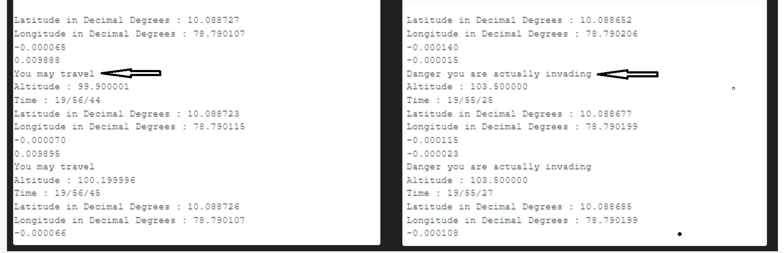

Figure 4.1

The above image depicts the output of our project. It shows various parameters like

* + - The current location in terms of decimal degree.
    - The difference in value of the boundary and the live location/
    - The warning message which is printed in the serial port.
    - An alarm which gets triggered during intrusion.

From the output we can infer that, if the boat enters the virtual boundary which we have created then we trigger the alarm indicating them that they are actually crossing the border and insisting them to return to safer fishing zone.

On the other hand if they are fishing in a safer zone, they will continue to fish in that zone until they move to the vicinity of the border.

**5**. **ERROR ANALYSIS**:

|  |  |  |
| --- | --- | --- |
| LANDMARKS | VARIATION OF LATITUDE AND  LONGITUDE ON DIFFERENT  TRAILS | ERROR CALCULATED |
| NEAR  KOLLANKAALI AMMAN TEMPLE | 1)Latitude=10.0089306  Longitude=78.793853  2)Latitude=10.00893062  Longitude =78.793859 | Long(2)-Long(1)=0.00006  Longitude value for  distance of 1m=0.000012075  Error = 0.00006/0.000012075  = 4.96m (approx) |
| CSE DEPARTMENT BUILDING | 1)Latitude =10.089306  Longitude =78.793853  2)Latitude =10.089306  Longitude =78.793853 | Long(2)-Long(1)=0.00007  Longitude value for  distance of 1m=0.000012075  Error = 0.00007/0.000012075  = 5.79m (approx) |
| EEE DEPARTMENT BUILDING | 1)Latitude =10.091175  Longitude =78.797645  2)Latitude =10.091178  Longitude =78.7938671 | Long(2)-Long(1)=0.000071  Longitude value for  distance of 1m=0.000012075  Error = 0.000071/0.000012075  = 5.8799m (approx) |

### 6. CONCLUSION

Our project work is a very small initiative which we were able to take, when we tried to solve this long lasting issue. We used the concept of Geo fencing to create a virtual boundary, kept a track on their live location and further alerted them if required.

A still more better remedy can be found to solve this problem and this issue of fishermen getting arrested repeatedly can completely come to an end when this issue is given more importance. Considering the livelihood of the fishermen we wish this issue to get a complete solution in the mere future.